Heaven’s light is our guide



RAJSHAHI UNIVERSITY OF ENGINEERING & TECHNOLOGY
Department of Mechatronics Engineering

Lab Report

Experiment No.:04
Experiment Name: Up-Down Seven Segment Display Counter using Atmega32 with Proteus Simulation

Submitted By: | Submitted To:
Samia Afsana  ID: 2008055  3rd Year , Odd Semester  Department of Mechatronics Engineering  Rajshahi University of Engineering & Technology, Rajshahi-6204. | Md Mehedi Hasan  Assistant Professor  Department of Mechatronics Engineering  Rajshahi University of Engineering & Technology, Rajshahi-6204.
Md. Sakib Hassan Chowdhury
Lecturer
Department of Mechatronics Engineering
Rajshahi University of Engineering & Technology, Rajshahi-6204.

Date of Experiment: 4 May, 2024
Date of Submission: 11 May, 2024

MTE 3104
Microcontroller and Interfacing Sessional
Experiment No.: 04
Experiment Name: Up-Down Seven Segment Display Counter using Atmega32 with Proteus Simulation.

Objectives:
- To design and implement a digital counter circuit using Atmega32 microcontroller.
- To create a circuit that can count up and down based on user input using push buttons.
- To interface the Atmega32 microcontroller with a seven-segment display to visually represent the count.
- To simulate the designed circuit in Proteus software to verify its functionality and performance.

Theory:
A 7-segment display counter typically operates by cycling through numerical values from 0 to 9, displaying each digit using a combination of illuminated segments. It's often controlled by a microcontroller or digital circuit, which sends signals to the display to update the digits sequentially. The theory behind its operation involves understanding how to activate the appropriate segments to represent each digit and how to synchronize the counting process with the desired timing. As its name suggests, a 7-segment display consists of seven segments, meaning it consists of seven light emitting diodes or LED’s, which together can be used to form one complete digit on the display. Actually most 7-segment displays contain eight internal LEDs as the eight one is used for a decimal point, usually in one of the bottom corners of the display [1].
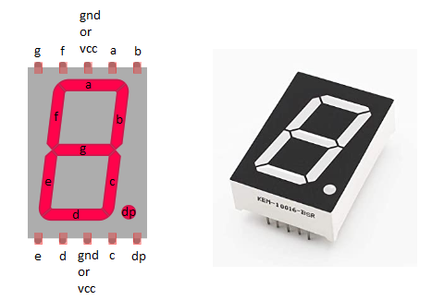
Figure- 4.1: Seven Segment Display [2].
So, if a 7-segment display consists of seven LED’s (ignoring the decimal point for now), one for each segment, and an LED has two terminals, an Anode and a Cathode, does that mean that each single 7-segment display will have 14 connecting pins or terminals.

Working Principle:
The code was executed to control a 7-segment display by configuring certain pins of the microcontroller's I/O ports for input and output operations. The function DisplayDigit was defined to display numerical digits on the 7-segment display.

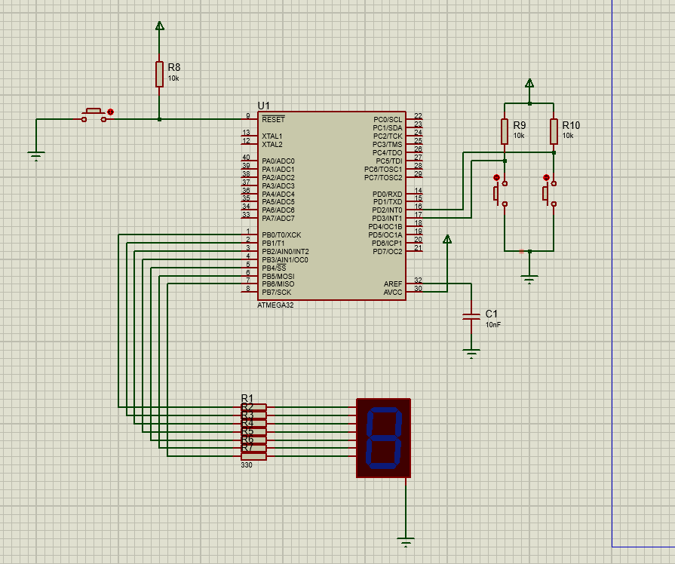
Figure- 4.2(a): 7-segment display (off phase)
In the main function, the I/O ports and a variable count were initialized to track the numerical value to be displayed. Initially, a '0' was displayed. Then, an infinite loop was entered where button presses were continuously checked. When a button was pressed, a debounce delay of 250ms was waited to stabilize the input signal.

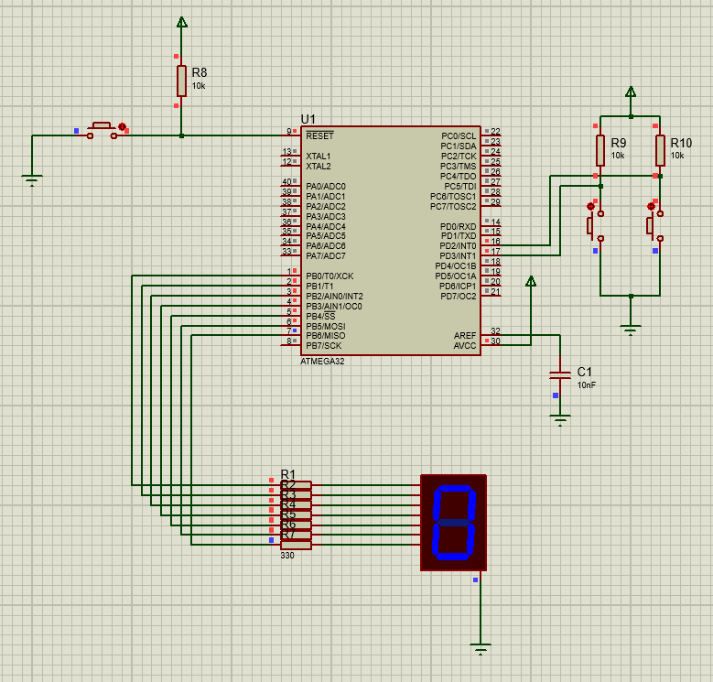
Figure- 4.2(b): 7-segment display active (digit 0)

After that, it was checked which button was pressed and the count variable was accordingly incremented or decremented if it was within the specified range. Subsequently, the display was updated to reflect the new count value using the DisplayDigit function.

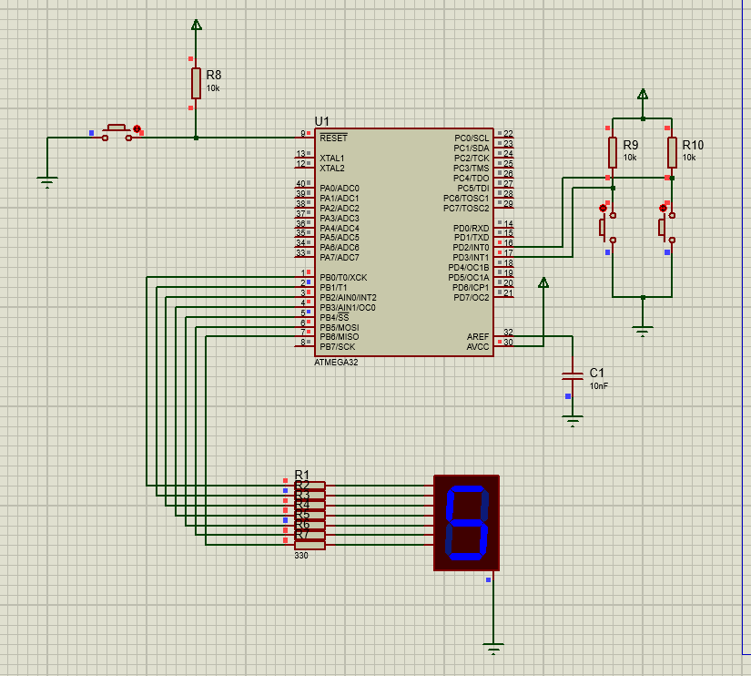
Figure- 4.2(c): 7-segment display active (digit 5)

Throughout the operation, the 7-segment display exhibited the numerical value corresponding to the count variable, which was either incremented or decremented based on the button press events.
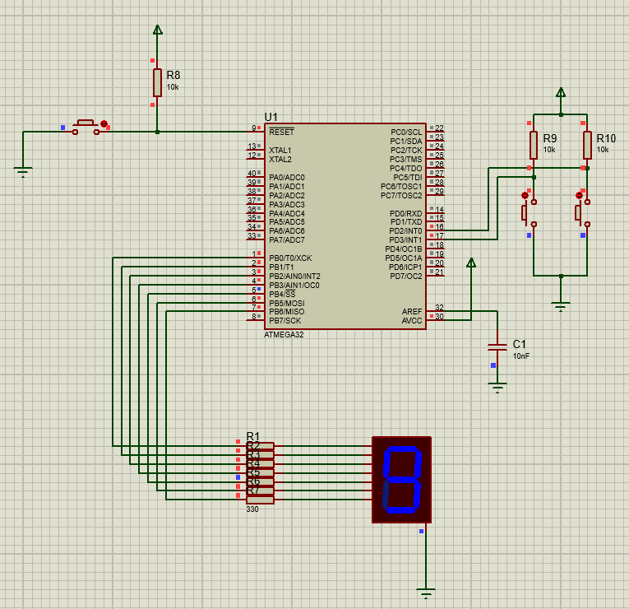
Figure- 4.2(d): 7-segment display active (digit 9)

Required Components:
- Atmega32 Microcontroller
- Seven Segment Display
- Power
- Capacitor
- Wire
- Ground-(4)
- Resistors
- Push Button-(3)
Code:

#include <avr/io.h>
#include <util/delay.h>
static void DisplayDigit(uint8_t num);
int main(void)
{
DDRB = 0x7F;
DDRD &=~ 0x0C;

uint8_t count= 0;
DisplayDigit(count);
while (1)
{
if((PIND & 0x04)==0)
{
_delay_ms(250);

if(count<9)
count++;
else
continue;

DisplayDigit(count);
}
if((PIND & 0x08)==0)
{
_delay_ms(250);

if(count>0)
count--;
else
continue;

DisplayDigit(count);
}
}
return 0;
}
static void DisplayDigit(uint8_t num)
{

PORTB &= 0x80;
switch(num)
{

default:
case 0:
PORTB |=0x3F;
break;
case 1:
PORTB |=0x06;
break;
case 2:
PORTB |=0x5B;
break;
case 3:
PORTB |=0x4F;
break;
case 4:
PORTB |=0x66;
break;
case 5:
PORTB |=0x6D;
break;
case 6:
PORTB |=0x7D;
break;
case 7:
PORTB |=0x07;
break;
case 8:
PORTB |=0x7F;
break;
case 9:
PORTB |=0x6F;
break;
}
}

Discussion:
During the simulation, the circuit was successfully implemented in Proteus software. The Atmega32 microcontroller accurately controlled the Seven Segment Display to count up and down based on the input signals (0-9 digits) from the buttons. The 7-segment display accurately reflected the binary count in real-time. The interfacing between the microcontroller and the display was seamless, demonstrating the effectiveness of the design.

Practical Uses:
- This project can be used in digital timers, scoreboards, and various counting applications.
- It serves as a learning tool for understanding microcontroller interfacing and programming concepts.
- It can be integrated into larger systems for more complex functionalities, such as controlling multiple displays or incorporating additional sensors.

Conclusion:
In conclusion, the experiment demonstrated the implementation of an up-down 7-segment display using Atmega32 microcontroller with Proteus Simulation. The project achieved its objectives of understanding microcontroller interfacing, programming, and implementing the 7-segment display functionality. This experiment serves as a fundamental building block for more advanced projects involving microcontrollers and digital displays.

References:
[1] 7-segment display [Online]. Available:
https://www.electronics-tutorials.ws/counter/7-segment-display.html (2024)

[2] Seven Segment Display [Online]. Available:
https://www.dotnetlovers.com/images/SevenSegmentDisplay7192020120357AM.png (2012-2023)

